**ORJIEH PATRICK SD1C PROJECT – BASED ON FOOTBALL GAME**

**LECTURER – Dr. DIANA BOGUSEVSCHI**

**LOG FILE AND CLASS DIAGRAM**

**08/04/2022**: At the end of the last programming I was able to get the basics of my project and what it would look like. Including my initial attributes for the objects.

Player: Name, Date of birth, Position, Nationality, Preferred foot

Team: Name, Location., Manager, ArrayList of Players, Ranking.

Didn’t do much on this today just tried to get the initial idea and representation of what the project would look like and do.

**12/04/2022:** Finished setting up all the getters and setters for both the player class and team class alongside doing testing in the testPlace class, then I created the compareTo and equals method of the Player Object and picking what I want the sort operator would reference. I realised that my attributes were subjected to just Strings, so I had to think of more attributes to add to the objects.

Player – name, dateOfBirth, shirtNo, position, foot, height, weight, nationality, marketValue

Team – name, location, manager, ranking, value, players

**14/04/2022:** After sorting out the player class, I decided to finish up where I stopped in the Team class, somewhere in the testing I realized that both the team and player class had a String called name, I didn’t really know if that would affect or not so I decided to change the name of the String in the Player class to namep(), after finishing the toString in the team, I went through the project specification document to get idea of the methods to create in the container class.

**15/04/2022:** Decided to think of what I actually wanted to do for my project and I got stuck in trying to turn my idea into reality and I got really confused so I decided to revise all topics in programming so far this semester

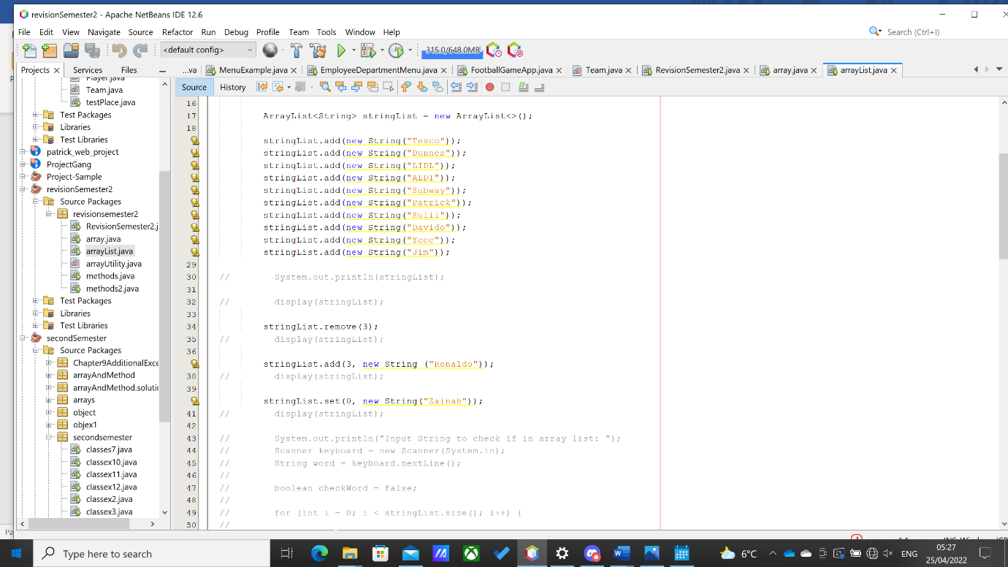

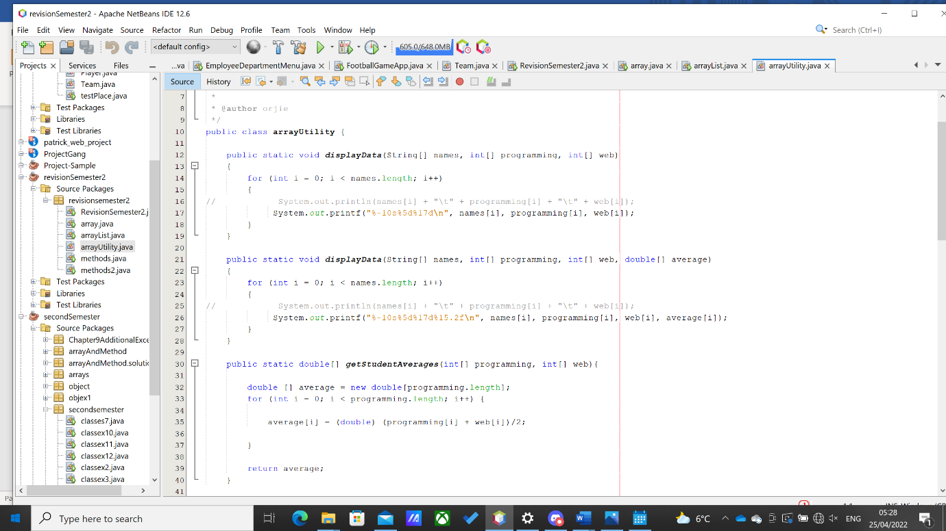

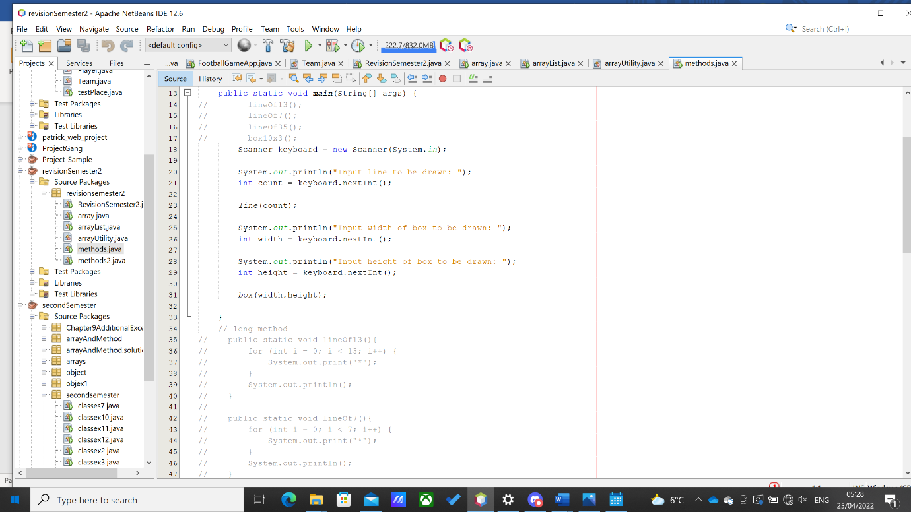

Those are some of the works I reviewed to get my head sort of back to the project.

**18/04/2022:** So, I watched all of the Anne’s Videos on moodle and learnt how she created all her methods with the public void, and I tried using static to create a method and I saw a message saying static method cannot be dereferenced. Created the addPlayer, displayPlayer, displayPlayerByName,getHighestMarketValue,deleteAll and sortByMarketValue.

**20/04/2022:** Created the footballManagerApp, tried visualizing the project idea so I created a file that had 10 teams and 11 players each for a team and ran it through the Scanner file to start the project, afterwards I prompted the user to create his team and I wanted to do the display in such a way that it prints out the football pitch and places out players in positions using the getPosition method but it didn’t come out as I wanted it to, I was stuck on this for hours and pretty much wasted time.

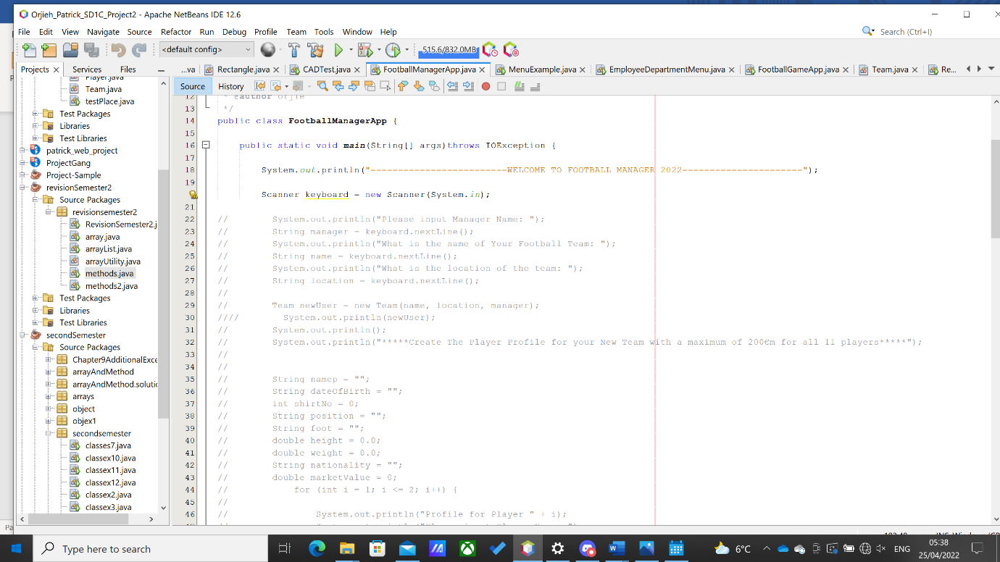

**22/04/2022:** Today, I want to implement another project idea but this will just be limited to 3 options, my project idea will run like the football manager game, will only have the career mode, where the user can create his team and it can have a match with a team of his choice thereby the match is simulated. Worked on this and it came out pretty fine, satisfied for the rest of the day.

**24/04/2022:** I noticed that I was short on methods and didn’t create all the methods in the project specification document and the count method ordered that the criteria should be done using the return, I tried on this but I think it has something to do with then fact that whenever the object compares with a double it shows an error about dereferencing, I had no choice so I created all the methods in the void style and while testing my getHighestMarkeyValue method works very well in my testing class but brings an error in the main app, I have no understanding to that but I left it like that.

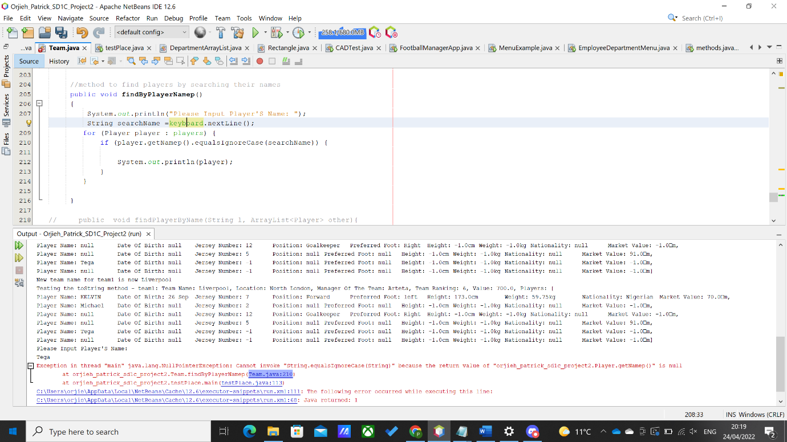

And another thing I learnt from the error above came as a result of some of the Player objects I used in testing and their names being empty so it brought that error, when I tested in the main app no error came up.

I tried mailing you on the error I got while doing the findBy and count method but I eventually got my way around it.